Fenner Town Board
Town Office Building – 8:03 PM
October 11, 2017

PRESENT: SUPERVISOR JONES
DEPUTY SUPERVISOR STRACK
COUNCILPERSON CODY
COUNCILPERSON PUSHLAR
COUNCILPERSON WESTER
HIGHWAY SUPERINTENDENT SMITH
TOWN CLERK STOKER

The regular meeting of the Fenner Town Board was called to order at 8:03 PM by Supervisor Jones with the pledge to the flag.

Councilperson Strack requested a correction to the September minutes, page 3, under the discussion regarding what the windmill company has paid in the past, a correction has been made to read that the Town will go from $200,000.00 to $75,000.00 a year. Councilperson Cody motioned to accept the September minutes as corrected. Seconded by Councilperson Pushlar. Approved by the Board.

Supervisor Jones- Aye
Councilperson Strack- Aye
Councilperson Cody- Aye
Councilperson Pushlar- Aye
Councilperson Wester- Aye

Councilperson Strack moved to accept the Special Meeting minutes in which the 2018 Preliminary Budget was handed out. Seconded by Councilperson Wester. Approved by the Board.

Supervisor Jones- Aye
Councilperson Strack- Aye
Councilperson Cody- Aye
Councilperson Pushlar- Aye
Councilperson Wester- Aye

Councilperson Wester motioned to accept the Town Clerk’s Monthly Report as presented. Seconded by Councilperson Pushlar. Approved by the Board.

Supervisor Jones- Aye
Councilperson Strack- Aye
Councilperson Cody- Aye
Councilperson Pushlar- Aye
Councilperson Wester- Aye

Councilperson Strack moved to accept the Supervisor’s Monthly Report as presented. Seconded by Councilperson Cody. Approved by the Board.

Supervisor Jones- Aye
Councilperson Strack- Aye
Councilperson Cody- Aye
Councilperson Pushlar- Aye
Councilperson Wester- Aye

Highway Superintendent Smith presented the Highway Department’s report. He informed the Board of the routine work that has been accomplished. Fenner East Road has been repaired by partnering with Madison County Highway Department, saving the Town of Fenner $16,000.00. The new Highway Department truck was delivered. Propane prices are being investigated to get the best offer for the season.

UNFINISHED BUSINESS:

Public hearing on Resolution No. 2017-9, “A local law authorizing a property tax levy in excess of the limit established in General Municipal Law Section 3-c for the 2018 fiscal year” was opened. A resident asked for a summary of the Resolution. No one was present to speak for or against.

RESOLUTION NO. 2017-9
TO THE TOWN BOARD
OF THE TOWN OF FENNER

A LOCAL LAW AUTHORIZING A PROPERTY TAX LEVY IN EXCESS OF THE LIMIT ESTABLISHED IN GENERAL MUNICIPAL LAW SECTION 3-C FOR THE 2018 FISCAL YEAR

WHEREAS, at the request of the Town Supervisor, the attorney for the Town has prepared and presented a proposed local law entitled, “A local law authorizing a property tax levy in excess of the limit established in General Municipal Law section 3-c for the 2018 fiscal year”, and

WHEREAS, the proposed local law is intended to authorize the Town of Fenner to exceed the tax levy cap otherwise provided under New York State law for the Town’s 2018 budget and fiscal year.

NOW THEREFORE IT IS HEREBY RESOLVED that the Town Board of the Town of Fenner will hold a public hearing October 11, 2017 at 8:05 p.m. at the Town of Fenner Town Hall to consider the proposed local law entitled, “A local law authorizing a property tax levy in excess of the limit established in General Municipal Law section 3-c for the 2018 fiscal year.”
Dated: September 13, 2017
Councilperson Wester motioned to close the Public Hearing. Seconded by Councilperson Cody. Approved by the Board.

Supervisor Jones- Aye
Councilperson Strack- Aye
Councilperson Cody- Aye
Councilperson Pushlar- Aye
Councilperson Wester- Aye

NEW YORK STATE DEPARTMENT OF STATE
41 STATE STREET
ALBANY, NY 12231
Local Law Filing

(Use this form to file a local law with the Secretary of State.)

Text of law should be given as amended. Do not include matter being eliminated and do not use italics or underlining to indicate new matter.

County
Village
of Fenner
Town
City

Local Law No. of the year 2017.

A local law authorizing a property tax levy in excess of the limit established in General Municipal Law §3-c
(Insert Title)

for the 2018 fiscal year.

Be it enacted by the Town Board of the

County
City
of Fenner as follows:
Town
City

Section 1. Legislative Intent
It is the intent of this local law to allow the Town of Fenner to adopt a budget for the fiscal year commencing January 1, 2018 that requires a real property tax levy in excess of the “tax levy limit” as defined by General Municipal Law § 3-c.
Section 2. Authority
This local law is adopted pursuant to subdivision 5 of General Municipal Law §3-c, which expressly authorizes a local government’s governing body to override the property tax cap for the coming fiscal year by the adoption of a local law approved by a vote of sixty percent (60%) of said governing body.

(If additional space is needed, attach pages the same size as this sheet, and number each.)

Section 3. Tax Levy Limit Override
The Town Board of the Town of Fenner, County of Madison, is hereby authorized to adopt a budget for the fiscal year commencing January 1, 2018 that requires a real property tax levy in excess of the amount otherwise prescribed in General Municipal Law §3-c.
Section 4. Severability
If a court determines that any clause, sentence, paragraph, subdivision, or part of this local law or the application thereof to any person, firm or corporation, or circumstance is invalid or unconstitutional, the court’s order or judgment shall not affect, impair, or invalidate the remainder of this local law, but shall be confined in its operation to the clause, sentence, paragraph, subdivision, or part of this local law or in its application to the person, individual, firm or corporation or circumstance, directly involved in the controversy in which such judgment or order shall be rendered.
Section 5. Effective date
This local law shall take effect immediately upon adoption.

(Complete the certification in the paragraph that applies to the filing of this local law and
Strike out that which is not applicable.)

1. (Final adoption by local legislative body only.)

I hereby certify that the local law annexed hereto, designated as local law No. of 2017 of the (County)(City)(Town)(City) of Fenner was duly passed by the
Town Board on October 11 , 2017, in accordance with the applicable provisions of law.
(Name of Legislative Body)

2. (Passage by local legislative body with approval, no disapproval or repassage after disapproval by the Elective Chief Executive Officer*.)

I hereby certify that the local law annexed hereto, designated as local law No. of 20 of the (County)(City)(Town)(City) of was duly passed by the on 20 , and was (approved)(not approved
(Name of Legislative Body)
(repassed after disapproval) by the and was deemed duly adopted
(Elective Chief Executive Officer*)
on 20________, in accordance with the applicable provisions of law.

- (Final adoption by referendum.)

I hereby certify that the local law annexed hereto, designated as local law No. of 20 of the (County)(City)(Town)(City) of was duly passed by the
on 20 , and was (approved) (not approved
(Name of Legislative Body)
(repassed after disapproval) by the on 20 .
(Elective Chief Executive Officer*)
Such local law was submitted to the people by reason of a (mandatory)(permissive) referendum, and received the affirmative vote of a majority of the qualified elector voting thereon at the (general)(special)(annual) election held on 20 , in accordance with the applicable provisions of law.

- (Subject to permissive referendum and final adoption because no valid petition was filed requesting referendum.)

I hereby certify that the local law annexed hereto, designated as local law No. of 20 of the (County)(City)(Town)(City) of was duly passed by the
on 20 , and was (approved) (not approved
(Name of Legislative Body)
(repassed after disapproval) by the on 20 .
(Elective Chief Executive Officer*)
Such local law was subject to permissive referendum and no valid petition requesting such referendum was filed as of 20 , in accordance with the applicable provisions of law.

____________
- Elective Chief Executive Officer means or includes the chief executive officer of a county elected on a county-wide basis or, if there be none, the chairperson of the county legislative body, the mayor of a city or City, or the supervisor of a town where such officer is vested with the power to approve or veto local laws or ordinances.

(City local law concerning Charter revision proposed by petition.)

I hereby certify that the local law annexed hereto, designated as local law No. of 20 of the City of
having been submitted to referendum pursuant to the provisions of section (36) (37) of the Municipal Home Rule Law, and having received the affirmative vote of a majority of the qualified electors of such city voting thereon at the (special) (general) election held on 20 , became operative.

- (County local law concerning adoption of Charter.)

I hereby certify that the local law annexed hereto, designated as local law No. of 20 of the County of , State of New York, having been submitted to electors of the General Election of November 20 , pursuant to subdivisions 5 and 7 of section 33 of the Municipal Home Rule Law, and having received the affirmative vote of a majority of the qualified electors of such cities of said county as a unit and a majority of the qualified electros of the towns of said county considered as a unit voting at said general election, became operative.

(If any other authorized form of final adoption has been followed, please provide an appropriate certification.)

I further certify that I have compared the preceding local law with the original on file in this office and that the same is a correct transcript therefrom and of the whole of such original local law, and was finally adopted in the manner indicated in Paragraph 1 , above.

_________________________________________________________
Clerk of the county legislative body, City, Town or City Clerk or officer designated
by local legislative body

(Seal) Date: ____________________________________________________

(Certification to be executed by County Attorney, Corporation Counsel, Town Attorney, City Attorney or other authorized attorney of locality.)

STATE OF NEW YORK
COUNTY OF MADISON

I, the undersigned, hereby certify that the foregoing local law contains the correct text and that all proper proceedings have been had or taken for the enactment of the local law annexed hereto.

Signature

Attorney for the Town
Title

County
Village
of Fenner
Town
City

Date:

Councilperson Strack made a motion to approve Local Law 2017-2. Seconded by Councilperson Pushlar. Approved by the Board.

Supervisor Jones- Aye
Councilperson Strack- Aye
Councilperson Cody- Aye
Councilperson Pushlar- Aye
Councilperson Wester- Aye

Wind Turbine #18 sound study lost its funding through the Cornell program, however the turbine was identified as needing service to have its generator replaced due to a faulty magnet. The company will replace that turbine.

NEW BUSINESS:

The Town has reviewed the road use and repair agreement with Canastota Windpower, LLC.
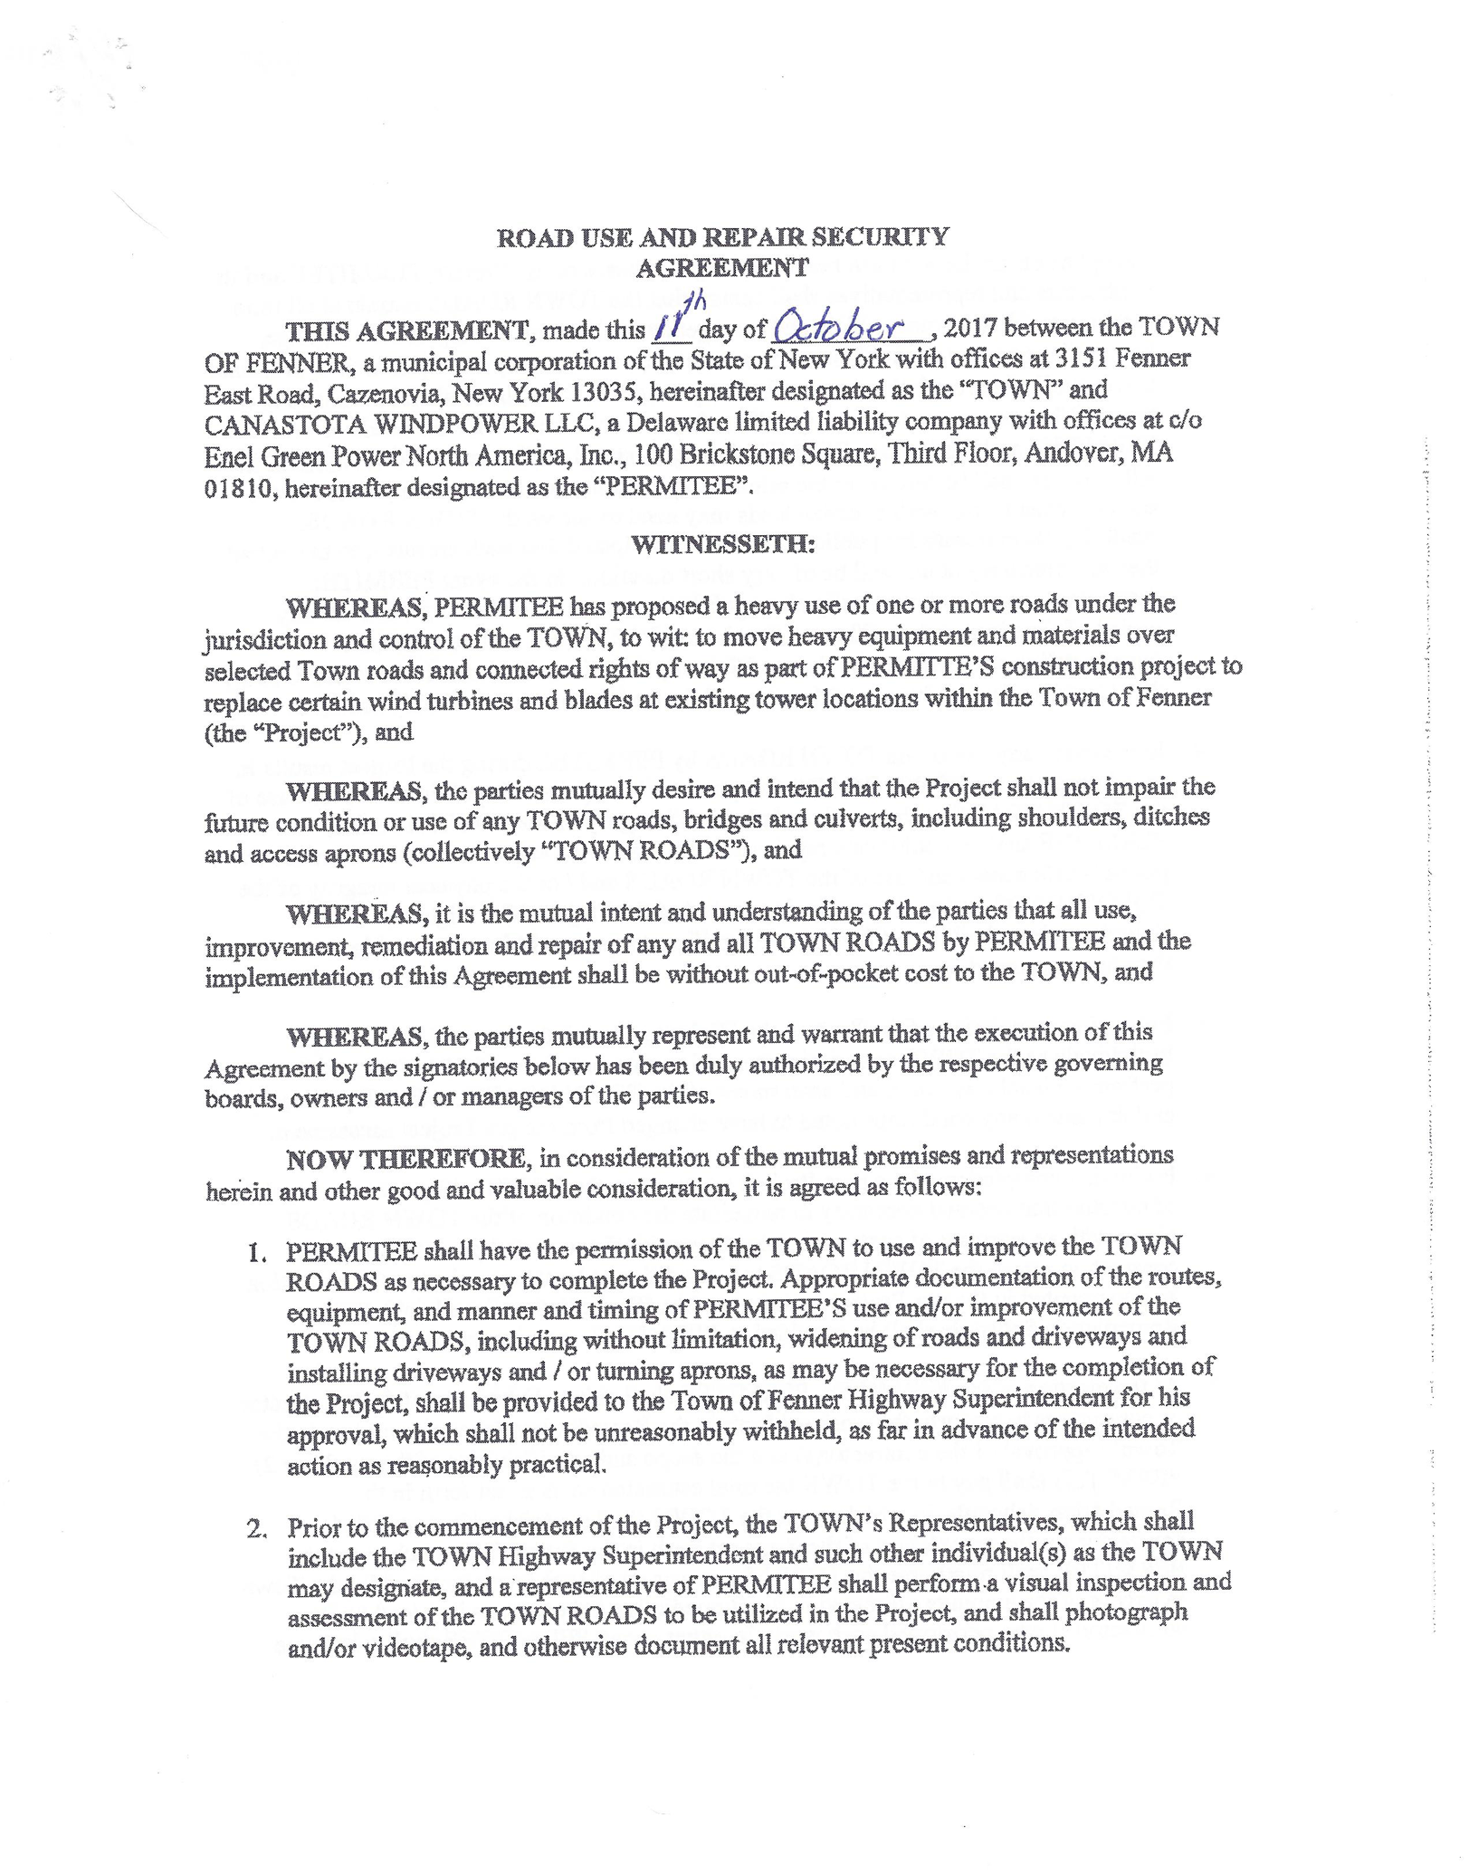
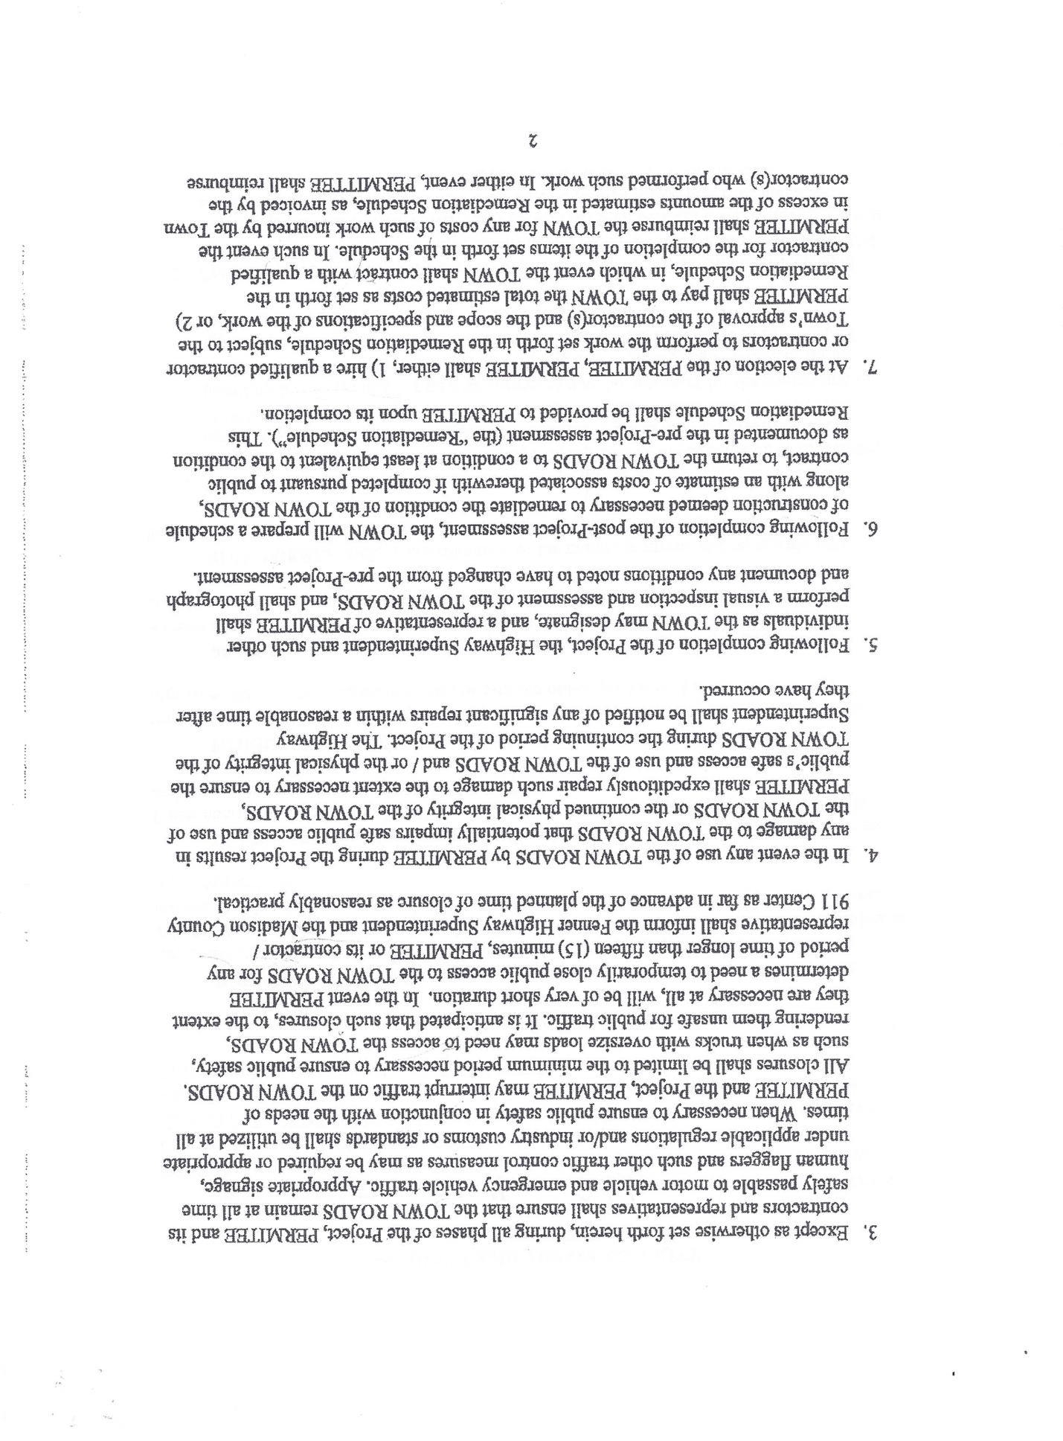

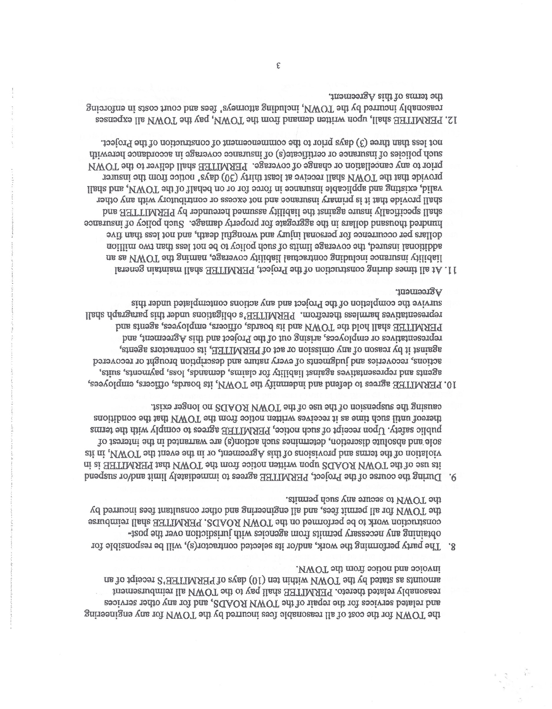

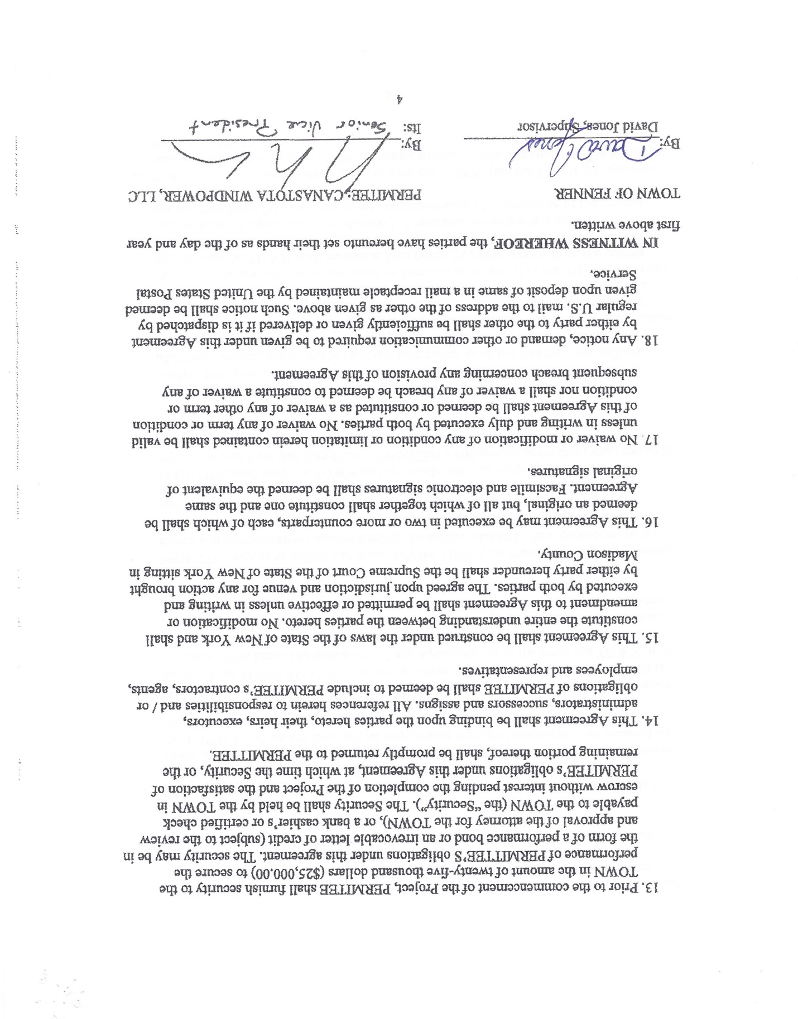

Supervisor Jones introduced Resolution No. 2017-10 titled, “A Resolution To Approve The Road Use and Repair Of Security Agreement With Canastota Windpower, LLC.” .

RESOLUTION NO. 2017-10
OF THE TOWN BOARD
OF THE TOWN OF FENNER

A RESOLUTION TO APPROVE THE ROAD USE AND REPAIR OF SECURITY AGREEMENT WITH CANASTOTA WINDPOWER, LLC

WHEREAS, Canastota Windpower, LLC Inc. was granted an amendment to its special permit in connection with its plans to replace certain of its currently existing wind turbines with new turbines, rotors and blades atop existing towers in existing locations (the “Project”) pursuant to a resolution duly adopted by the Town of Fenner Planning Board dated July 19, 2017 (“the Planning Board Approval”), and

WHEREAS, one of the conditions of the Planning Board Approval is that “a building permit not be issued until such time as …a road maintenance agreement has been entered into with the Town of Fenner to warrant the maintenance and repair of Town roads impacted by the construction of the Project.”, and

WHEREAS, Canastota Windpower, LLC and the Town of Fenner have negotiated the terms and conditions of a Road Use and Repair Security Agreement, the execution of which is intended to fulfill the aforesaid condition.

NOW, THEREFORE BE IT HEREBY RESOLVED that the Town Board of the Town of Fenner does hereby approved the Road Use and Repair Security Agreement between the Town and Canastota Windpower, LLC as negotiated and presented, and it is hereby

FURTHER RESOLVED that the Town Supervisor be and hereby is authorized to execute on behalf of the Town of Fenner the said Road Use and Repair Security Agreement between the Town of Fenner and Canastota Windpower, LLC.

Dated: October 11, 2017

Councilperson Wester made a motion to approve Resolution No. 2017-10. Seconded by Councilperson Strack. Approved by the Board.

Supervisor Jones- Aye
Councilperson Strack- Aye
Councilperson Cody- Aye
Councilperson Pushlar- Aye
Councilperson Wester- Aye

The Municipal Electric and Gas Alliance (MEGA) program to help stabilize energy costs and protect residents from predatory marketing practices was introduced by Supervisor Jones. More information on this program will be coming soon.

Supervisor Jones introduced Resolution No. 2017-11 titled, “A Resolution to Establish A Position Of Part-Time Bookkeeper”.

RESOLUTION NO. 2017-11
OF THE TOWN BOARD
OF THE TOWN OF FENNER

A RESOLUTION TO ESTABLISH A POSITION OF PART-TIME BOOKKEEPER

WHEREAS, the Town Board deems it in the public interest, and in the best interest of the Town of Fenner to create a new part time position of assistant bookkeeper.

NOW, THEREFORE, IT IS HEREBY RESOLVED that the Town Board of th town of Fenner does hereby created and establish the part time position of assistant bookkeeper, whose duties shall be to assist the Town bookkeeper with the functions of that position, and it is hereby further

RESOLVED that the part time bookkeeper shall not work more than 145 hours per fiscal year. And shall be paid at the rate of $27.50 per hour, with no additional non-salary employment benefits associated with this position, with the exception of any required payments to the New York State Public Employees’ Pension Plan, and shall and it is hereby further

RESOLVED, that Jennifer Stoker be, and hereby is hired to fill the position of part time assistant bookkeeper effective October 11, 2017.

Dated: October 11, 2017

Supervisor Jones continued noting that each position has a deputy in place in the event the person in that position is unable to perform his or her duties due to health or family needs. He feels it is in the best interest of the Town to have this position in place. Councilperson Pushlar motioned to accept Resolution No. 2017-11. Seconded by Councilperson Cody. Approved by the Board.

Supervisor Jones- Aye
Councilperson Strack- Aye
Councilperson Cody- Aye
Councilperson Pushlar- Aye
Councilperson Wester- Aye

Supervisor Jones noted the Preliminary 2018 Budget has had a few changes made. Changes include, the amount needing to be raised by taxes to be adjusted from $531,000 to $490,000. Much of that reduction comes from the Highway Departments budget, the Workman’s Comp costs, as well as $25,000.00 received from the County for being next door to a host community for the local casino operation. At this time, we have not needed to dip into our Tax Stabilization Fund. We started at $5.34 per $1000 and it is down to $3.87 per $1000. That is up $0.80 from a year ago. The Town has needed to put extra money in for our attorney, as the pending court costs for the conflict with the windmill company is still unknown. There has been an increase in employee benefits over the last 2 years of over $21,000.00. Our fire protection/CAVAC is up over 4% over the last 2 years. And the Town needed a new truck as we were putting thousands of dollars into repairs for the vehicles we currently run. The one replaced was 18 years old with over 200,000 miles on it. We will keep it through the winter as a spare, off the insurance to save money. The insurance can be put on with a phone call.

PUBLIC COMMENTS:

A resident asked where the Town is currently at with the legal issues with the windmill company. Supervisor Jones explained the matter with company is currently before Judge Cerio. They are seeking to get the assessment reduced. It will be some time until we have complete picture of the situation. They were put on the tax rolls at an assessed value of 25 million dollars and they feel they should be assessed at 4 million dollars. Last year $78,000.00 was paid in tax, and this year the taxes would be $12,000.00.

OTHER BUSINESS:

Highway Superintendent Smith continues to work with FEMA representatives to determine an accurate amount expended by the Town during Winter Storm Stella.

Ribbon cutting ceremony will be held on October 19, 2017 for the solar project at ARE park aka landfill.
VOUCHERS:

Councilperson Pushlar moved to approve payment of the General Fund claims numbers 126-135 in the amount of $938.32 as set forth in abstract number 9 and as audited. Seconded by Councilperson Strack. Approved by the Board.

Supervisor Jones- Aye
Councilperson Strack- Aye
Councilperson Cody- Aye
Councilperson Pushlar- Aye
Councilperson Wester- Aye

Councilperson Strack moved to approve payment of the Highway Fund claims numbers 106-122 in the amount of $76,217.04 as set forth in abstract number 9 and as audited. Seconded by Councilperson Cody. Approved by the Board.

Supervisor Jones- Aye
Councilperson Strack- Aye
Councilperson Cody- Aye
Councilperson Pushlar- Aye
Councilperson Wester- Aye

Councilperson Wester made a motion to adjourn the meeting. Seconded by Councilperson Pushlar. Approved by the Board. Meeting adjourned at 9:00 p.m.

Supervisor Jones- Aye
Councilperson Strack- Aye
Councilperson Cody- Aye
Councilperson Pushlar- Aye
Councilperson Wester- Aye

Handouts and Reports: On file in Town Clerk’s Office
Code Enforcement Ofcr. Rpt. – September 2017
Town Clerk Rpt. – September 2017
Supervisor’s Rpt. – September 2017
Hwy. Superintendent Rpt. – September 2017
Dog Control Ofcr. Rpt. – September 2017

By Order of the Town Board
Jennifer Stoker
Fenner Town Clerk

